MANCETTER PARISH COUNCIL

You are invited to the Parish Council Meeting of the Parish of Mancetter,
to be held in the schoolroom of St Peter’s Church Mancetter
on Tuesday 23rd November 2021 at 7pm prompt.

Can members of the public please confirm attendance with the Clerk prior to the meeting by emailing parishclerk@mancetter.org.uk or telephoning 07368 265051 so that COVID 19 risk assessment guidance can be explained.

AGENDA

- Welcome and Coronavirus Risk Assessment.

- Apologies.

- Chairman’s request that anyone recording the meeting make themselves known.

- Notice of Interest.

- Public Question time up to 15 Minutes for Members of the Public to raise issues.
It is still advised that queries or concerns are raised with the clerk prior to the meeting, in order to minimise the time spent within the building.

- Minutes of the last meeting:

- To accept the draft minutes of the Parish Council Meeting held on 28th September 2021.

- Matters Arising from the Parish Council Meeting on 28th September 2021.

- Tarmac Quarry: Liaison meeting date, funding and complaint updates.
- Parish Councillor Vacancy.
- Feedback from Traffic and Speed surveys.
- Village Signs and Roman Heritage board.

- Brief Report from the Police, County and Borough Councillors.

- Any other Parish Business for Discussion- not covered in any other agenda points

- Information from the A5 Stakeholder Focus Group October 2021.

- Update on recent meeting and progress for the Platinum Jubilee celebrations within Mancetter and Ridge Lane.

- Training and Events

- Feedback from the virtual WALC Annual Conference on Climate Change Friday 22nd and Saturday 23rd October 2021.

- The booking of training and event places through WALC for Councillors including Local Climate Action days.

- WALC AGM feedback and Clerk training.

- Planning Matters and New Applications: Update on recent Planning Applications, Enforcement Issues and Determinations from Planning Lists.

Pending Applications and Enforcement Issues

- Update on the proposed development at the White Hart Public House in Ridge Lane.

- PAP/2021/0177 – 19 Nuneaton Road Mancetter

- PAP/2021/0484 – Fir Tree Paddock Quarry Lane Mancetter.

- PAP/2021/0506 – The Barn Mill Lane Mancetter

- PAP/2021/0545 – Ladywood Farm Ridge Lane

Applications Determined

PAP/2021/0537 – 4 Mancetter Road Mancetter – Granted.
PAP/2021/0530 – 9 The Spinney Mancetter – Granted.

New Applications to be discussed:

PAP/2021/0607 - 4 Mancetter Road (additional rear extension)
PAP/2021/0609 - 37 Daniel Road

- Finance

- Signing of all payments since the last meeting in accordance with the Bank mandate.

- To consider and approve in principal, the 2022/2023 draft Parish Council budget in preparation for the precept request once the tax base has been confirmed in January 2022.

- To discuss any Grant Applications received.

- To approve the Chairman’s discretionary payment towards refreshments for the Parish Gathering on 22nd September 2021.

- To decide whether to renew the service contract with Dell Computers at an annual cost of £49.20 per PC.

- Cemetery and Maintenance around the Parish.

- To consider bringing forward the purchase of the Platinum Jubilee specialist trees for the cemetery, to assist with the water table and ensure that planting takes place in the dormant growing season.

- To discuss the use of slabs to mark out the position of plots in the new cremation area and the removal of unauthorised memorials.

- Update on Cemetery Railings Project.

- Date of next meeting-

Tuesday 25th January 2022

Parish Council Meeting 7pm at St Peter’s Church Mancetter.

Signed

Date 18th November 2021.

Elane Higgins
Parish Clerk Mancetter Memorial Hall Old Farm Road Mancetter CV9 1QN Tel: 01827 722552 Email: parishclerk@mancetter.org.uk

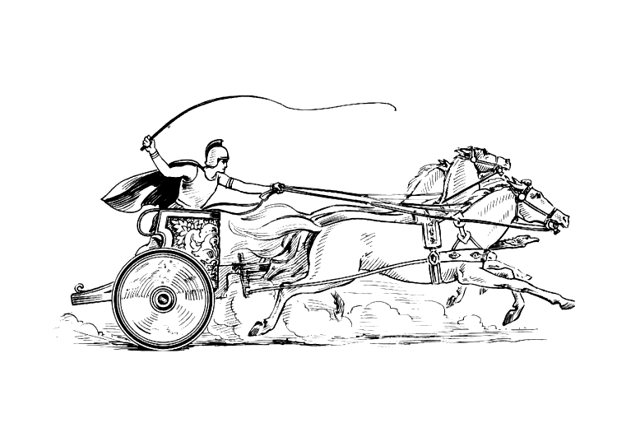

Manduessedum - Mancetter Village
(Place of War Chariots)
Mancetter Parish Council
Serving the People of Mancetter and Ridge Lane

